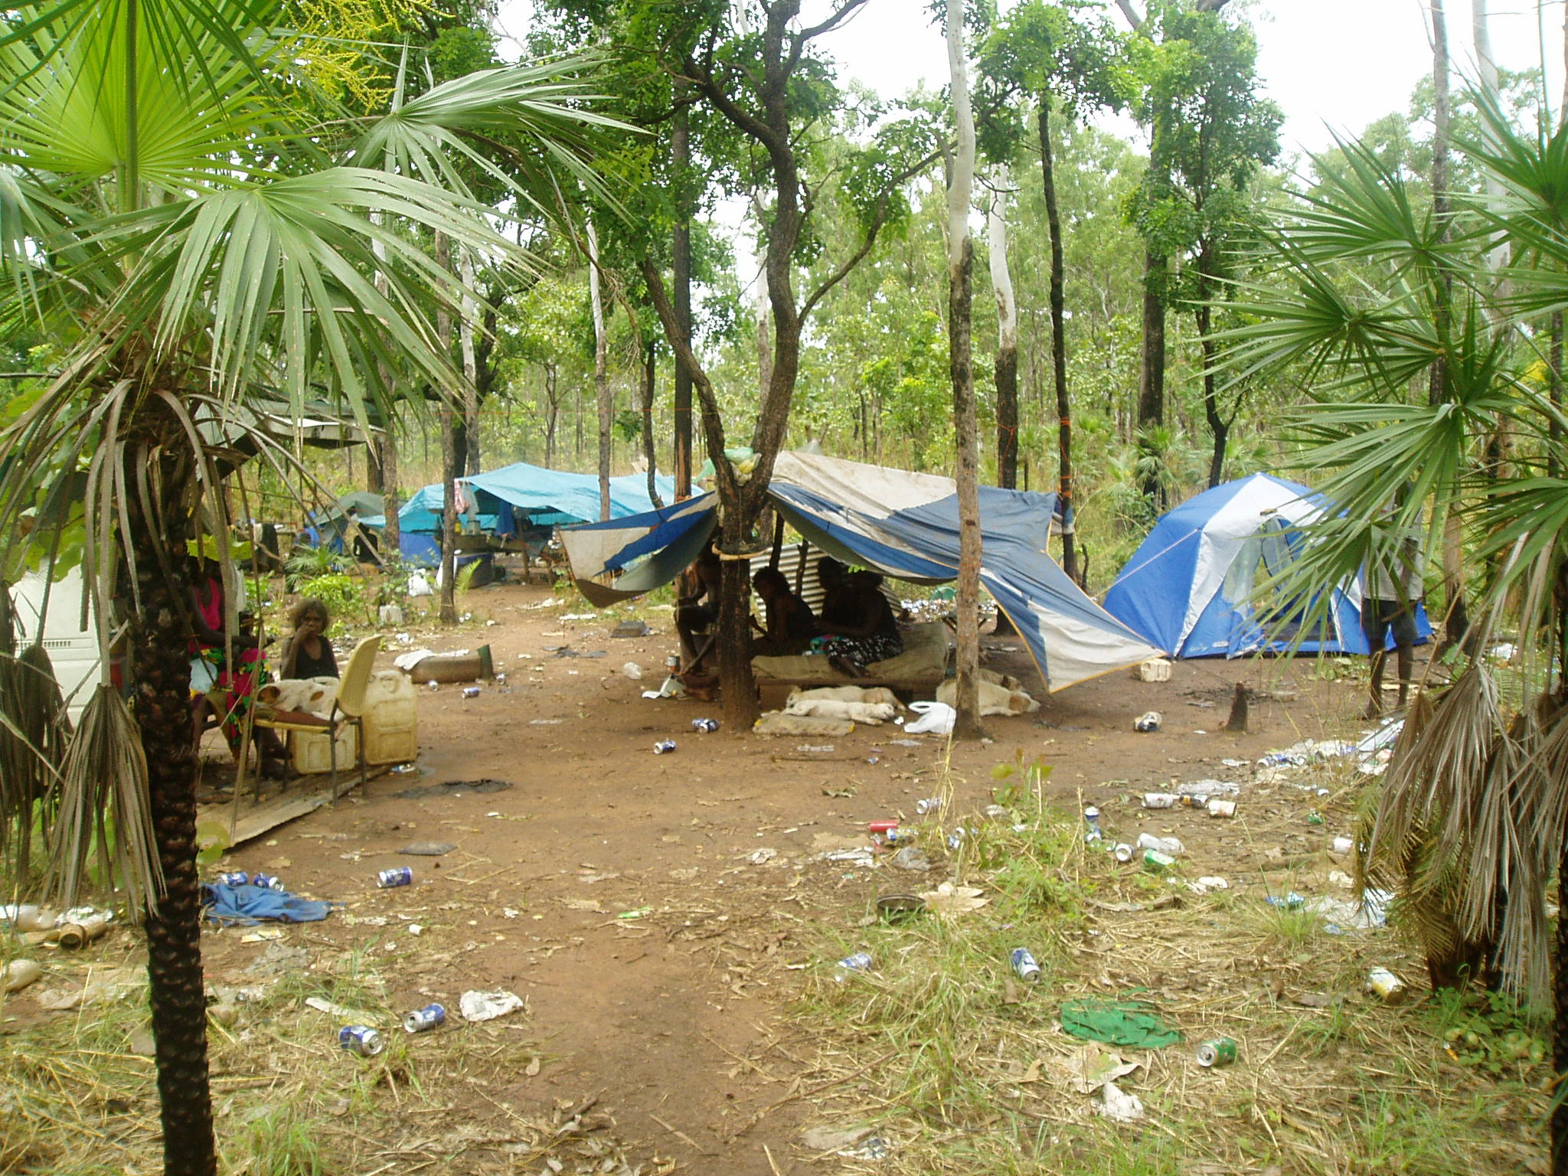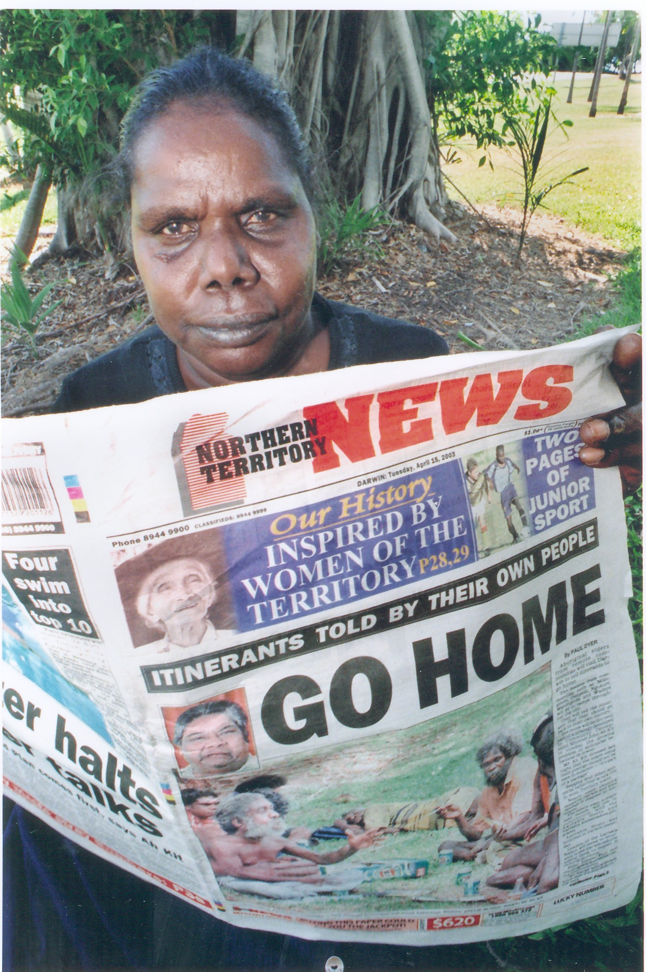

In 2008 Aboriginal people, sometimes called ‘long grass people’, still live in camps around Darwin - without toilets, running water or electricity. These ‘long grass people’ continue to ask for a place to camp without being harassed by the City Council or police. The Northern Territory Government tells them to go back to their country, but for some of the campers Darwin is their home. They will never forget the courage of Gojok, a ‘long grass’ man who died for the rights of his people.

Thanks to
NT News, ABC Television, Star Newspapers,
Bill Day, Vaughan Williams, Stella Smith,
Stuart and Robbie Courtenay,
Anda Fellows and Jeannie Gadambua.
for the photos and stills.

Dedicated to the people of Fish Camp and Lee Point

This booklet printed
2009
by
Bill Day
PO Box 425
Maylands
WA 6931

